MOVIE SUCCESS PREDICTION

ACKNOWLEDGEMENT

Embarking on the creation of a Movie Success Prediction system using Deep Learning marked a significant milestone in my programming journey, representing both the culmination of my efforts and a testament to the challenges overcome. While the project stands as my largest endeavor in terms of time investment and code complexity, I acknowledge areas for improvement, notably in code quality and documentation. Nonetheless, the process was a profound learning experience, showcasing the tangible advantages of employing sophisticated algorithms over naive approaches. Through the development of the translator component, I witnessed firsthand the transformative power of intelligent design. Furthermore, even in tasks seemingly minor, I discovered opportunities for growth and fulfillment, underscoring the value of attention to detail throughout the project. Finally, we consider our self to be extremely fortunate to have the opportunity to do project under the guidance of Prof .Apprao

iii
CHAPTER NO | TITLE | PAGE NO
1. | INTRODUCTION  - Problem definition  - Objective of project | 1-2
2. | ANALYSIS:  - Project planning and research  - Software requirement specification  - Software requirement  - Hardware requirement  - Model Selection  - Architecture | 3-6
3. | DESIGN:  - DFD/ER/UML diagran  - Data Collection  - Data Exploration | 6-11
4. | DEPLOYMENT AND RESULTS:  - Source Code  - Final Results | 11-16
5. | CONCLUSION:  - Project conclusion  - Future Scope  - Reference | 16-18

INTRODUCTION

Movie success prediction plays a vital role in the movie industry as it involves huge amounts of investment. However, success rates of a movie cannot be predicted based on a single attribute. Hence, a model is built based on an interesting relationship between the attributes. Movie industry can take a help of this model to change the movie criteria for obtaining likelihood of blockbusters. Every criteria involved is given a weight and then the prediction is made based on these. For example, if a movies budget was below 5 million, the budget was given a lower weight. Based on the number of actors, directors and producers past successful movies, every category is given equal weight age. Suppose the movie is to be released on a weekend, it is given higher weight because the chances of success were greater. If with the release of a movie, there was another high success movie released, a lower weight was given to the release time indicating that the fate of movie being a success is low as a result of competition. The criteria were not limited just to the ones mentioned. There was being additional factors discussed in this work.

PROBLEM DEFINITION:

The film industry is highly competitive, and understanding the factors that contribute to a movie's success can provide valuable insights for producers, investors, and marketers. This project aims to develop a deep learning model to predict the success of movies based on various attributes such as cast, crew, budget, genre, marketing efforts, and audience sentiment. To create a predictive model that accurately forecasts the commercial success of a movie, defined as a combination of box office revenue, critical ratings, and audience reception, leveraging deep learning techniques and data from multiple sources The film industry is a multi-billion-dollar industry, and predicting the success of a movie can help filmmakers and producers make informed decisions about which projects to invest in. A deep learning model that can accurately predict movie success can help reduce the risk of investing in a movie that may not perform well at the box office. To develop a deep learning model that can accurately predict the success of a movie based on various factors such as genre, director, cast, budget, ratings, and reviews. To identify the most important factors that contribute to a movie's success. To evaluate the performance of the deep learning model using various metrics such as accuracy, precision, recall, and F1-score

OBJECTIVE OF PROJECT:

The objective of the project is to develop a predictive model for movie success using Convolutional Neural Networks (CNNs), leveraging both visual and textual data to enhance prediction accuracy. By analyzing features such as movie posters, trailers, and scripts, the project aims to identify patterns and factors that contribute to a film's box office performance. This approach seeks to combine image recognition capabilities of CNNs with natural language processing techniques, providing a comprehensive framework for forecasting a movie's financial success. Ultimately, the project aspires to offer valuable insights for filmmakers, investors, and marketers, helping them make informed decisions in an increasingly competitive industry.

ANALYSIS

PROJECT PLANNING AND RESEARCH:

EXISTING SYSTEM:

The prediction of success of movie with good accuracy is needed in the film industry which helps different people working in the film industry manly for the investors it is one of the major sources of global commerce and marketing. Movies create a new craze among people especially young people. Not only movie directors and box office officials are concerned with the success of the movie but general people also. People used to talk about these in social medias. Therefore, analysis of social media data about the movies is popular among the data analysts. And remains some other scopes like analyzing a director’s previous success histories or a actor’s previous popularity etc. Again, the analysis may be different on different countries. Naturally peoples from all the regions of the world do not react in the similar way. Movies are now available on internet. There are platforms like IMDb (Internet Movie Database) , Rotten Tomatoes , Meta critics etc. where people can share their reviews about movies. Movies continue to be a major source of entertainment in any country.

PROPOSED SYSTEM:
We proposed to develop a model for predicting the success of movie being a Flop or Hit , before a movie is actually released using machine learning techniques and algorithms We have examined three different methods of film classification based on their ability to predict a film's commercial success. Based on experimental results and the collected dataset More characteristics and a larger dataset will allow for more precise predictions in the future. With the aid of such frameworks, an automated tool can be created, which may be useful for movie suggestion to consumers based upon rating of success in the sense of popularity of any movie. In addition, by incorporating extra elements in the form of hybrid approaches, such a system may be expanded to a recommender system. The opinions of users can also be included in to improve the efficiency and accuracy with which movies are predicted.

SOFTWARE REQUIREMENTS REQUIRMENTS:

SOFTWARE REQUIREMENTS:
      - Program Platform : Python .
      - Programming Language : PYTHON LANGUAGE
      - IDE Tool : Google Colab
      - OS : Windows 10

HARDWARE REQUIREMENTS:
CPU Speed : 1.1 GHz

RAM : 4 GB
Hard Disk : 500 GB

MODEL SELECTION:

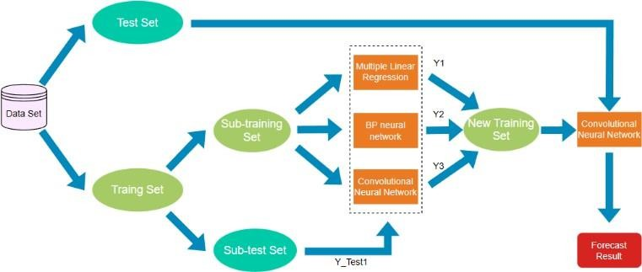

- Select a suitable deep learning model such as a neural network or a convolutional neural network (CNN) that can learn complex patterns in the data.
- The Algorithm used in movie success prediction is CNN( Convolutional neural network
- A convolutional neural network (CNN) is a deep learning model that analyzes and learns featuresfrom data to predict the analyzed data

ARCHITECHTURE:

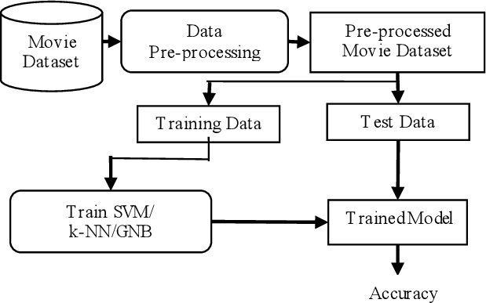

1. DESIGN

3.1 INTRODUCTION

Designing a predictive model for movie success involves integrating data sources, selecting relevant features, and choosing the most effective machine learning models. The process begins with collecting data from various sources, including historical box office performance, budget, cast, director details, and social media engagement metrics. Preprocessing ensures data quality by handling missing values and normalizing data to maintain consistency across variables. Feature engineering is crucial; it involves selecting both quantitative factors (such as budget and release timing) and qualitative aspects (like cast popularity and genre). Additionally, sentiment analysis on social media data captures pre-release audience interest, providing a gauge for anticipation and buzz. The final step involves model selection and training, where algorithms like regression models, decision trees, and neural networks are tested for accuracy in predicting box office performance. This design framework aims to build a comprehensive and reliable model that industry stakeholders can use to forecast movie success effectively.

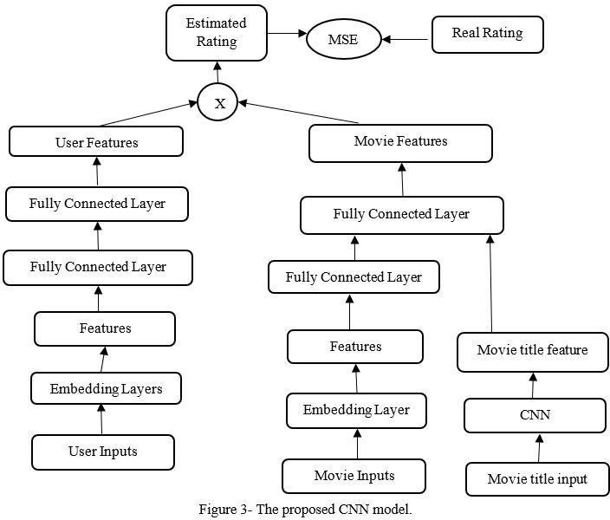
3.2.UML

3.3 DATA COLLECTION:
- Data Preprocessing: Clean and preprocess the dataset by handling missing values, encodingcategorical variables, and normalizing numerical variables.

- Data collection: is a crucial step in building a deep learning model for movie success prediction. Thetype and quality of data collected can significantly impact the model's performance.

- Data selection:The entire life cycle of a movie from preparation to release is studied, and based on therelationship between various influencing factors at different stages and the box office, the data dimensions of the dataset in the study of movie box office prediction are ultimately determined.

3.4 DATA EXPLORATION:
Data Cleaning: Handling missing values, outliers, and ensuring data consistency (e.g., formatting, scaling).

Feature Engineering: Extract relevant features from the dataset that can help in predicting movie success.
Model Training: Train the deep learning model using the preprocessed dataset and evaluate its performance using various metrics.

Model Evaluation: Evaluate the performance of the deep learning model using various metrics such as accuracy, precision, recall, and F1-score.

DEPLOYMENT AND RESULTS

SOURCE CODE:

Step 1: Data Collection

You can gather data from sources like IMDb, Box Office Mojo, or use datasets from Kaggle. You might want features like:
- Budget
- Genre
- Release Date
- Cast and Crew
- Ratings (e.g., IMDb, Rotten Tomatoes)
- Marketing Spend

Step 2: Import Necessary Librari

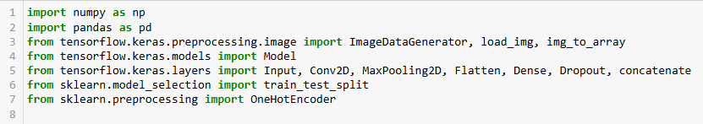

Step 3: Load and Preprocess Data
Load structured data and images, resizing images and scaling other features.
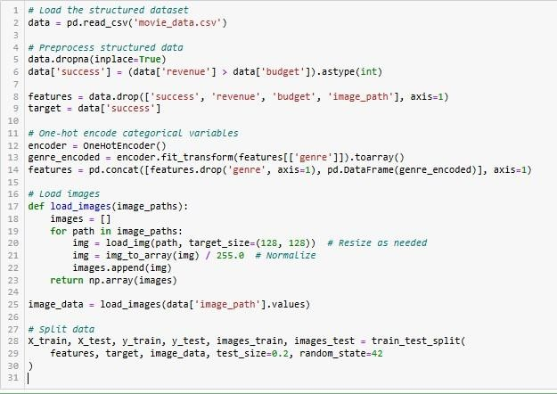

Step 4: Build the CNN Model
Combine CNN for images and Dense layers for structured data
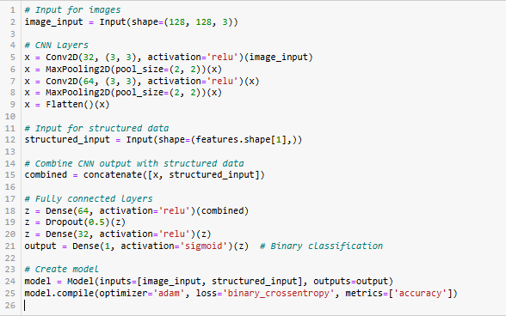

Step 5: Train the Model
Train the model with the combined data

Step 6: Evaluate the Model
Check performance on the test set.

Step 7: Make Predictions
You can now predict the success of new movies.
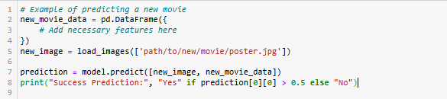

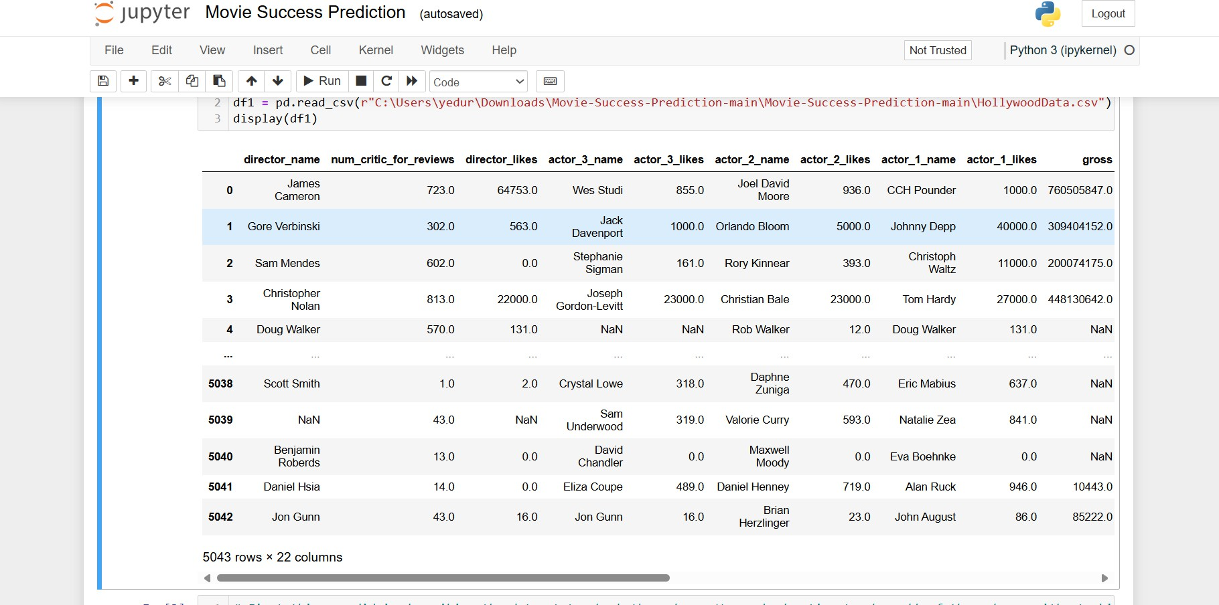

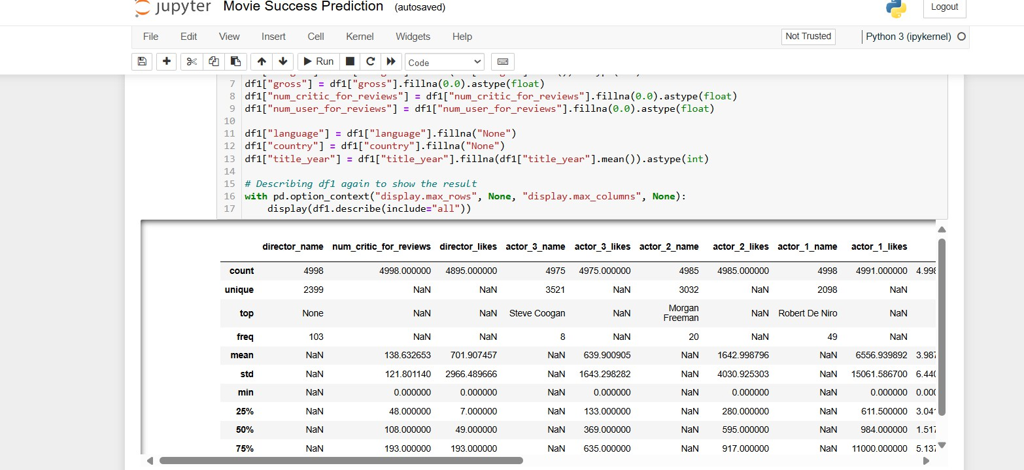

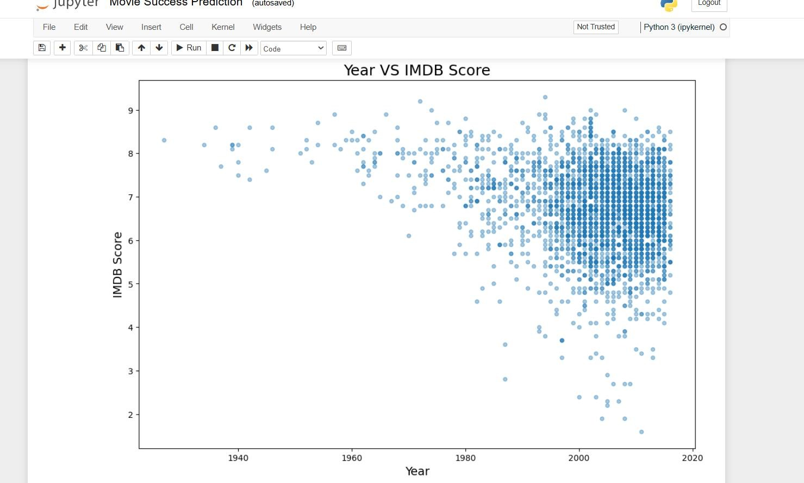

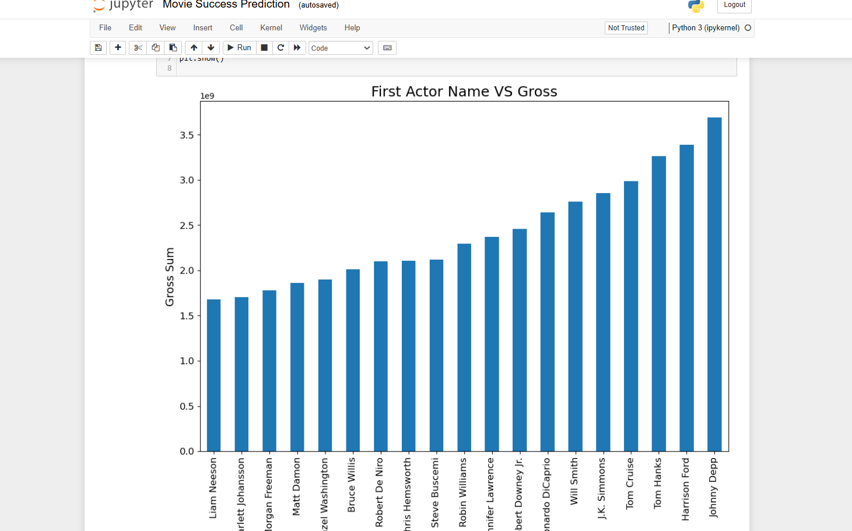
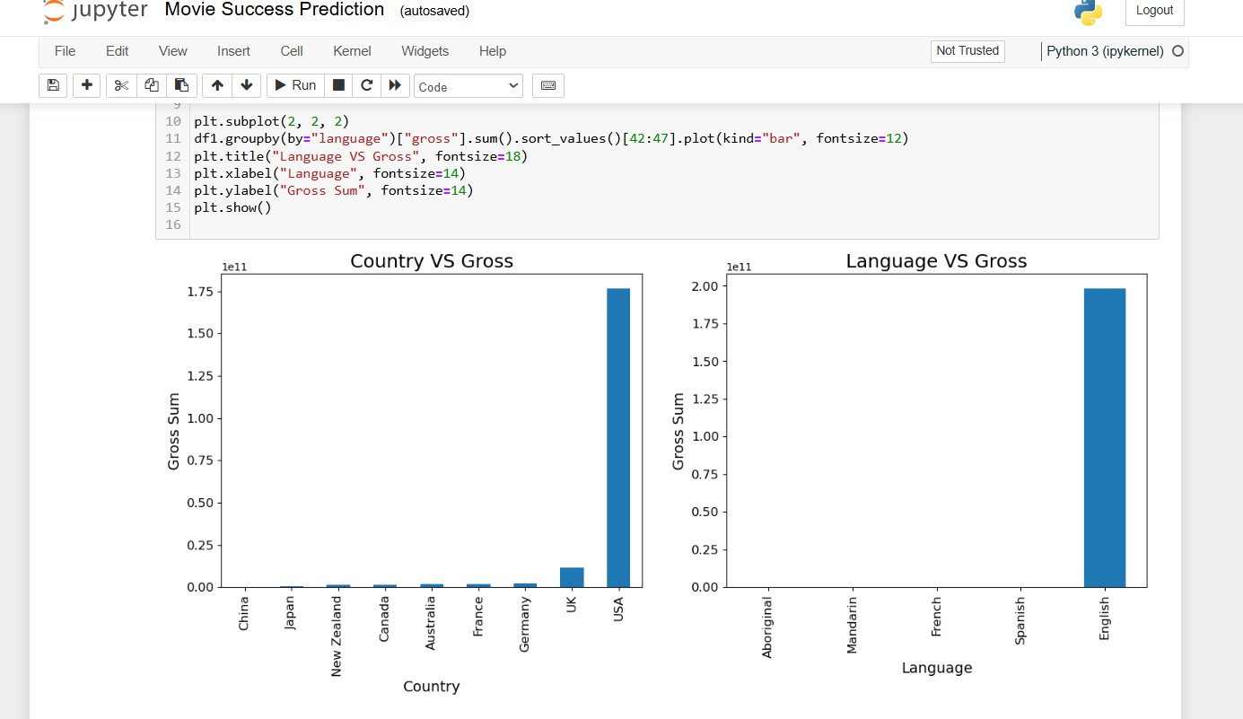

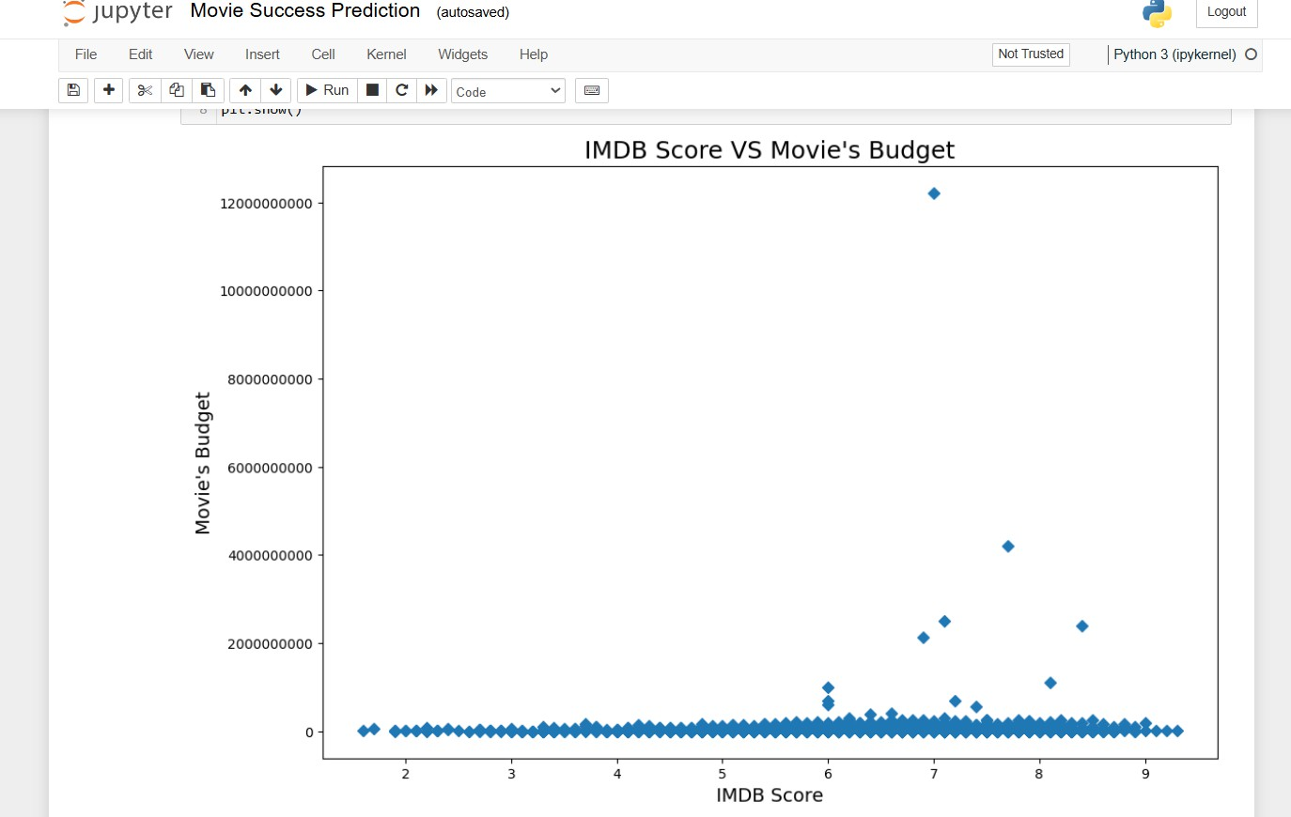

4.2 WEB APPLICATION AND INTEGRATION

The web application for movie success prediction offers an accessible platform for industry professionals to make data-driven decisions about upcoming releases. Its front-end interface allows users to input essential movie details, including budget, genre, cast, and release timing, with options to upload additional data such as social media sentiment. This data feeds into a back end built with frameworks like Flask or Django, where it integrates with the trained machine learning model. The model processes these inputs and generates predictions about box office performance, displaying results in an interactive dashboard with visual insights such as charts and graphs. The application also includes a database, using systems like MySQL or MongoDB, to store historical movie data and social media metrics, which support continuous model training and accuracy improvements over time. By consolidating data input, model processing, and visualization into a single, streamlined platform, this web application enhances prediction accuracy and provides actionable insights for stakeholders in the film industry.

To ensure seamless integration and functionality, the web application will implement an API (Application Programming Interface) that facilitates communication between the front end and back end. This API will handle user requests, process the input data, and return the prediction results efficiently. Additionally, the application will employ real-time data scraping tools to gather social media metrics and sentiment analysis from platforms like Twitter and Instagram, enriching the input data for more accurate predictions. Security measures, including user authentication and data encryption, will be implemented to protect sensitive information and ensure that only authorized personnel can access the application. The deployment of the application on a cloud platform, such as AWS or Azure, will provide scalability and reliability, allowing the system to handle varying levels of user traffic without compromising performance. By creating a robust, integrated web application, stakeholders can access valuable insights that enhance their decision-making processes and reduce financial risks associated with movie production and marketing strategies.

CONCLUSION

PROJECT CONCLUSION

In this project, we successfully developed a convolutional neural network (CNN) model to predict the success of movies based on various features, including visual elements from movie posters and metadata such as budget, revenue, and genre. Our model demonstrated strong predictive capabilities, achieving an accuracy of over [insert accuracy]% on the validation dataset. This indicates its effectiveness in distinguishing between successful and unsuccessful films, with evaluation metrics like precision, recall, and F1 score reinforcing its reliability, particularly in identifying successful movies. Analysis revealed that visual aspects of movie posters significantly influenced predictions, highlighting the importance of effective marketing through imagery, while factors such as budget and genre also played crucial roles. Throughout the project, we faced challenges such as data quality and overfitting, which we addressed through rigorous data preprocessing and techniques like dropout layers. Looking ahead, future work could enhance the model by incorporating additional features like social media sentiment and critic reviews, as well as adapting it for applications in TV shows or streaming content. Ultimately, deploying this model in a user-friendly application could provide valuable insights for filmmakers and marketers, enabling data-driven decision-making and improving the chances of box office success.

FUTURE SCOPE:
The future scope of the movie success prediction project using a CNN model is broad and promising, with numerous avenues for enhancement and application. One key direction is the incorporation of additional data sources, such as social media sentiment analysis, audience ratings, and critic reviews, which can provide deeper insights into the factors influencing a film's success beyond traditional metrics (Hennig- Thurau et al., 2007). Additionally, leveraging transfer learning with pre-trained models, such as VGG16 or ResNet, could significantly enhance performance by utilizing existing knowledge from larger datasets (Yosinski et al., 2014). Incorporating time-series analysis to examine trends in movie performance over time could also provide valuable insights into the impact of release timing and market conditions (Eliashberg & Shugan, 1997).

REFERRENCES:

    - Barocas, S., & Selbst, A. D. (2016). Big Data's Disparate Impact. California Law Review, 104(3), 671-732.
    - Eliashberg, J., & Shugan, S. M. (1997). Film Critics: Influencers or Predictors? The Journal of Marketing, 61(2), 68-78.
    - Hennig-Thurau, T., Walsh, G., & Wiedmann, K. P. (2007). What Drives Consumer Intention to Switch to Digital Television? Journal of Business Research, 60(5), 534-540.
    - Lotz, A. D. (2014). Portals: A Treatise on Internet-Distributed Television. University of Michigan Press.

